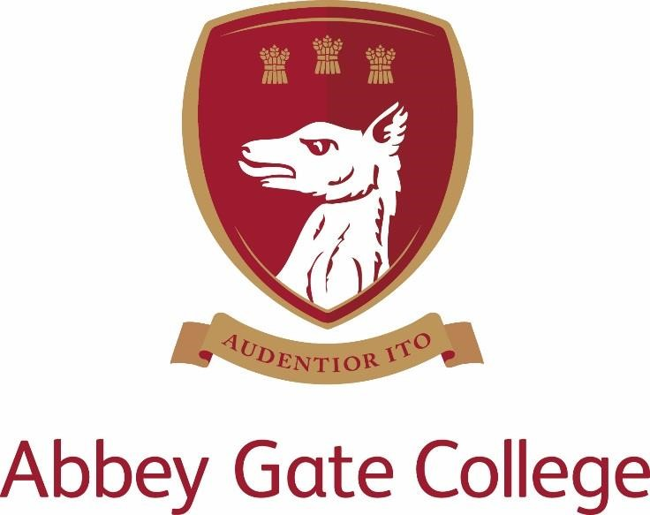

PART TIME TEACHER OF BUSINESS
(Temporary maternity cover)

Required From : 1 September 2021 until approx.15 October 2021(October Half term)

The College

Abbey Gate College is situated in superb surroundings south of the historic city of Chester. It was founded as an independent coeducational 11-18 School in 1977 under the Deeside House Educational Trust, as a charitable foundation. Our Infant and Junior School is sited in the old village school at Aldford, 2½ miles from the main site at Saighton. Academic results in all subjects are excellent and 100% pass rate at A level and GCSE is the norm. Most of our Sixth Form students go on to university. The College has a three form entry at Year 7 from an annual Entrance Examination held in January; places are oversubscribed and there are waiting lists operating at some age groups in the College.

The Post

We are seeking an enthusiastic teacher to teach GCSE and A Level Business. The successful candidate will be an outstanding practitioner with strong subject knowledge. They also need to demonstrate that they are highly motivated, enthusiastic and committed to high academic standards as well as being able to communicate an enthusiasm for the subject.

The role is Part Time working 0.65 FTE over three days (Monday, Tuesday, Wednesday). The position is to cover (part) of a maternity leave within the department and is required from 1 September 2021 until at least 15 October 2021 (possibly into November to be confirmed).

The use of ICT in delivering Business is good and pupils are expected to bring their own devices to lessons. Class sizes are small with the maximum number of pupils around 17 but many groups are smaller than this. Results are excellent and pupils regularly achieve above and beyond their target grades. There are a growing number of pupils opting to take Business at GCSE and A Level and the successful candidate would be expected to ensure this continues. A large number of pupils go on to study Business/Economic degrees at some of the top universities after their A Level studies.

A wide array of pupils with varying abilities choose Business at GCSE and in the Sixth Form. We believe that every pupil should be challenged to ensure they are achieving the best of their ability. Key assessments are set every half term and intervention is put in place to ensure all pupils achieve at least their minimum target grades. We encourage every pupil to attain the highest grades of which they are capable, to develop a positive attitude to learning and most of all to enjoy their learning experience.

Curriculum and extra-curricular responsibilities

GCSE pupils have three 55 minute lessons per week, Lower Sixth students have five 55 minute lessons per week and Upper Sixth students have six 55 minute lessons per week.

GCSE groups tend to be taught by a singular teacher whereas A Level groups are team taught, splitting the number of lessons between 2 teachers, each teacher responsible for teaching their own ‘Theme’.

All pupils follow the new 2015 Edexcel specifications and there is a strong focus on teaching and practicing exam technique from the start and throughout each course to help pupils attain the highest possible grades.

AS exams are currently being taken by students to gain an overview of their progress and to help them decide which subjects to continue to A Level.

The small class sizes allow for strong support and a personalised learning approach for all pupils. Off site visits enhance learning and various extra-curricular activities are run to help put the classroom theory into practice. Revision and exam technique sessions are also run during lunch times in the Spring and Summer terms the stretch the ablest and support any pupils that may be struggling.

Key qualities and person specification: -

The person appointed should show and demonstrate the following skills and qualities:

- Proven track record of successfully teaching Business at KS4 and KS5
- Ability to organise, plan, teach, and evaluate high quality, inspiring lessons and make necessary assessment of learning.
- Ensure effective communication/consultation as appropriate with the parents of pupils, contributing to events designed to advise pupils about the curriculum and future career paths.
- Excellent ICT skills to prepare and deliver lessons and for general administration of the role.
- Flexible approach to teaching and ability to adapt to remote teaching if required.
- Highly organised and have the ability to prioritise work effectively.
- Excellent interpersonal skills with staff, students, and parents
- Capable of maintaining high professional standards at all times
- Work collaboratively alongside the Head of Department and other staff in the College
- Show good planning skills and effectively use data to do this
- Ability to organise and run visits to enhance and enrich the curriculum
- To carry out professional duties in a positive, helpful and courteous manner.
- High expectations of pupils
- Optimism, enthusiasm and energy
- Ability to work to deadlines
- Professional integrity
- Ability to work calmly under pressure

Salary

The salary for this position will depend upon the qualifications and relevant experience of the successful candidate.

Child Protection

Abbey Gate College regards as paramount the welfare and safety of children. Whilst criminal convictions are not necessarily a bar, this safety consideration will be key to all decisions regarding the employment of staff, approval of volunteers and standards of external contractors. Pre-employment checks include but not limited to an enhanced DBS, check of the children’s barred list and suitable references.

Equal Opportunities

We are committed to treating all employees with dignity and respect regardless of race, ethnic background, nationality, colour, gender, transgender status, pregnancy, age, sexual orientation, religion or belief. We therefore welcome applications from all segments of the community.

Applications

Candidates should complete an Abbey Gate College Application Form and submit this together with a letter explaining their interest in and suitability for the post addressed to Mrs Tracy Pollard, Headmistress.

Candidates will meet the Headmistress, Deputy Head, Director of Studies, Director of Teaching and Learning Head of Business and Economics.

References will be obtained prior to interview, please inform your referees.

Please send your application to Rebecca.upton@abbeygatecollege.co.uk the HR and Compliance Manager.

Please see our website at www.abbeygatecollege.co.uk for more information about the College and our Privacy notices.

