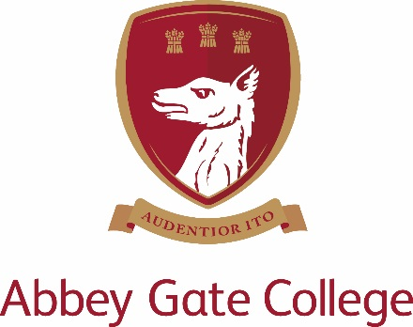

JOB DESCRIPTION
WEEKEND CARETAKER

Abbey Gate College is the longest-running co-educational independent school in the Chester area, catering for boys and girls aged 4-18. We are committed to safeguarding and promoting the welfare of children and young people and expects all staff and volunteers to share this commitment. The successful applicant will need to undergo an Enhanced DBS disclosure and Barred List checks.
- POST DETAILS

JOB TITLE: Weekend Caretaker (Part Time, Seasonal, Fixed term until 31 August 2022)
REPORTING TO: Estates Manager
PURPOSE OF JOB: The role is to supervise the weekend operations at the senior school site such as sports matches and external bookings of facilities by community groups and sports clubs. Ensure the health and safety of all members of the public whilst on site and that all areas are left clean and tidy ready for the commencement of the following school week.
KEY TASKS AND RESPONSIBILITIES:
Specific to Role
- Opening / locking up of all buildings that are going to be in use each day, ensuring site is completely secured and all alarms correctly set before site is vacated at night.
- Janitorial duties such as replenishment of hygiene products in washrooms.
- Ensuring that the site is kept clean and tidy at all times, to include litter collection, emptying bins, removing all waste etc. to the appropriate area.
- Cleaning tasks as required throughout the day to ensure all areas ready for following day.
- Ensure that the College rules are followed by members of the public visiting site such as no smoking, no dogs etc.
- Turning the floodlights on/off at the appropriate times.
- Moving hockey/football goals into position and setting out any equipment hired in advance by the groups.
- Be on hand to guide visitors to the right locations and help with general enquiries.
- To carry out any required maintenance work while working at the College as instructed by the Estates Manager.
- To carry out any additional responsibilities as requested by the Estates Manager or College as and when required.

Support for the College
- To support the College’s commitment to safeguarding children and promoting their welfare at a level appropriate to this role.
- Be aware of and comply with policies and procedures relating to health and safety, security, confidentiality and data protection, reporting all concerns to the appropriate person
- Contribute to the overall ethos/work/aims of Abbey Gate College;
- Participate in training, meetings, and performance development activities as required.

COMPETENCIES, SKILLS & EXPERIENCE
- Prior experience in caretaking / facilities management role desirable
- Must have a positive and enthusiastic approach
- Punctuality and reliability are essential
- Ability to plan work under own initiative
- Excellent inter-personal, communication and organisational skills
- Excellent customer service skills
- Ability to work constructively as part of the team of staff at Abbey Gate College
- Flexibility to work additional hours if required

QUALIFICATIONS
- Minimum GCSE English and Maths grade A - C (or equivalent)
- Full clean driving licence
- Basic Health and Safety / First Aid qualification would be an advantage

HOURS OF WORK
8 hours per weekend, every weekend between September and April (35 weeks’ work).
Working 8am until 5pm (with one hour unpaid lunchbreak to be taken in the middle of the day) however some flexibility in hours would be required.
There is the possibility of more hours during the summer (April to August) depending on facilities bookings.
PAY AND CONDITIONS
This role is fixed term until 31 August 2022 in the first instance.
Salary inclusive of 5.6 weeks’ holiday including bank holidays (pro-rated).
Inclusion in College Stakeholder Pension Scheme with employee contributions matched up to 5% of salary.
Job Type: Permanent
Salary: £9.85 /hour
APPLICATIONS
To apply for this position please complete the Abbey Gate College application form and return to Rachel.kennedy@abbeygatecollege.co.uk . Please include a cover letter explaining why this position is of interest to you.
The deadline for this position is 2nd August 2021 at 12 noon
Please note, we will not accept applications/CVs from recruitment agencies.

