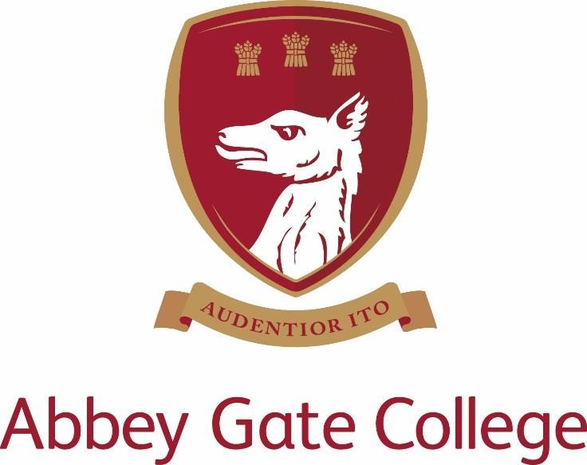

English & RE Teacher (maternity cover – Part Time)
Required from: 29th November 2021
Job Description and Person Specification

Introduction from the Head
Our wonderful Senior School and Sixth Form are enviably located in the historic Saighton Grange buildings, with stunning views across beautiful countryside towards the Welsh mountains and the Cheshire sandstone ridge; and our dedicated Infants and Junior School is just down the road in the charming and picturesque village of Aldford.

Our College is a unique, inspiring, and memorable place to learn and grow, where our caring and committed teaching and support staff will do all that they can to help our pupils to be the best that they can be.

We are a safe and friendly school community, where we look out for each other and where we work with each child’s individual interests, passions, and strengths; while also encouraging them to try new things, take risks, and be creative.

Our aim is to lead and coach our pupils during these critical, formative years, so that they may leave us at the end of Sixth Form having achieved the best that they can academically; and with a clear sense of who they are as a person and how they can go on to make a positive difference to our world in the uncertain future ahead – with courage and with compassion.

Thank you for taking the time find out more about us. If you feel that you could bring the right balance of care, commitment, expertise, and enthusiasm to this role, we would welcome your application.

Craig Jenkinson, MA (Oxon), PGCE, MInstLM

The Post
We are seeking an enthusiastic and committed teacher of English and RE to join our College to cover maternity leave. The successful candidate will become part of an experienced, mutually supportive and dedicated English team, and teach across Key Stage 3 in the senior school. As a department we frequently exchange ideas and appraise student progress in order to develop what we do; we are eager to challenge and be challenged through innovative and interesting ways of delivering our subject. Our overall aim is to develop confident, eager and independent learners, who are able to communicate clearly.
The teaching in RE is a standalone teaching role that covers lessons at Key Stage 3, Year 7, 8 & 9. The successful candidate will be responsible for delivering the schemes of work in line with the College’s policies and the assessing, tracking and monitoring of pupils at regular intervals. Through the delivery of RE, our aim is to foster secure critical thinking skills and enable pupils to consider and respond to a range of important questions related to their own spiritual development, the development of values and attitudes and fundamental questions concerning the meaning and purpose of life.

Curriculum
English is taught in sets throughout KS3 and 4; pupils are placed in appropriate sets to best support their learning from early in Year 7, once initial assessments have been completed. (Our approach to setting is, however, flexible and students are regularly monitored and, if necessary, moved to ensure the highest possible achievement.) Set sizes are usually between fifteen and twenty. In Years 7, 8 and 9 pupils also take the English Speaking Board examinations. Pupils take EDUQAS GCSE English Language and EDUQAS GCSE English Literature. At KS5 both subjects are offered: AQA English Language and OCR English Literature.

English pupils have four 50 minute lessons a week in Years 7 & 8, three lessons in Year 9 and five lessons in Year 10 & 11. There are five AS lessons and 6 A Level lessons per week.

In RE pupils have one 50 minute lesson a week in Years 7, 8 & 9. Class sizes are usually between eighteen and twenty-two and are mixed ability. Pupils are taught in line with the national recommendations, focusing on the six major religions along with themes focused on philosophical and ethical issues.

This role is required to cover 7 Key Stage 3 English lessons and 9 Key Stage 3 RE lessons.

Key Qualities and Person Specification
The person appointed should show and demonstrate the following skills and qualities:

- Inspirational teacher
- Enthusiastic, innovative and creative
- Ability to teach across the curriculum, including Key Stage 3 RE
- Be abreast of new trends and educational developments related to the subjects
- Excellent communication skills
- Committed to raising standards and monitoring pupil progress
- Outstanding professional and personal qualities
- Caring, supportive and willing to adapt their teaching to suit the needs of the pupils
- Willingness to lead extra-curricular sessions
- Act as a good role model to staff and pupils
- Proficient with the use of ICT in the classroom
- Excellent planning skills
- Well-organised
- Calm under pressure

Terms and Conditions of Employment
The salary and benefits for this position are competitive and will depend upon the qualifications and relevant experience of the successful candidate.

Child Protection
Abbey Gate College regards as paramount the welfare and safety of children. Whilst criminal convictions are not necessarily a bar, this safety consideration will be key to all decisions regarding the employment of staff, approval of volunteers and standards of external contractors.

Equal Opportunities
We are committed to treating all employees with dignity and respect, regardless of race, gender reassignment, pregnancy and maternity, age, sexual orientation, sex, religion or belief, marriage and civil partnership, and disability. We, therefore, welcome applications from all members of the community.

Process for Applications

Deadline: 1st October 2021
Interviews: Week commencing 11th October

Please apply by completing our Abbey Gate College application form along with a covering letter addressed to the Head, Mr Craig Jenkinson, explaining your interest and suitability for the role, and returning it to hr@abbeygatecollege.co.uk

The interview process will include; meeting the Head and Deputy Head. The candidate will be asked to conduct an English lesson and there will be a one to one with the Head of Department. There will also be a tour of the College. Specific details will be shared with shortlisted candidates in advance.

References for shortlisted candidates will be taken up prior to interview, please inform your referees.

Please visit our website at www.abbeygatecollege.co.uk for more information about the College.

