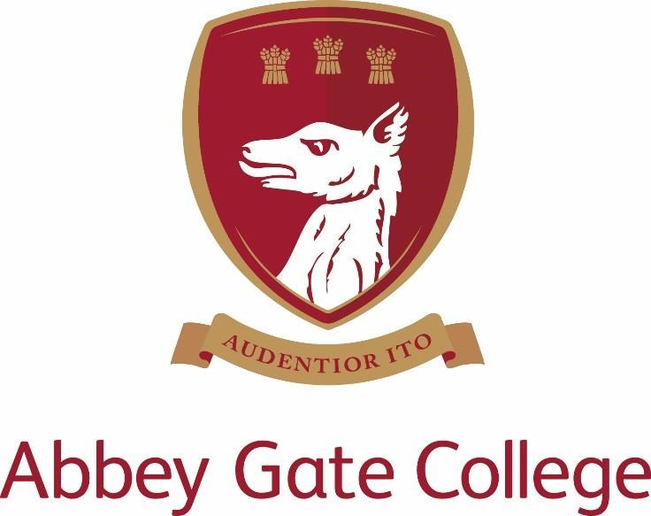

Head of Psychology (maternity cover – part time over 5 days)
Required from: 4th January 2022

Job Description and Person Specification

Introduction from the Head
Our wonderful Senior School and Sixth Form are enviably located in the historic Saighton Grange buildings, with stunning views across beautiful countryside towards the Welsh mountains and the Cheshire sandstone ridge; and our dedicated Infants and Junior School is just down the road in the charming and picturesque village of Aldford.

Our College is a unique, inspiring, and memorable place to learn and grow, where our caring and committed teaching and support staff will do all that they can to help our pupils to be the best that they can be.

We are a safe and friendly school community, where we look out for each other and where we work with each child’s individual interests, passions, and strengths; while also encouraging them to try new things, take risks, and be creative.

Our aim is to lead and coach our pupils during these critical, formative years, so that they may leave us at the end of Sixth Form having achieved the best that they can academically; and with a clear sense of who they are as a person and how they can go on to make a positive difference to our world in the uncertain future ahead – with courage and with compassion.

Thank you for taking the time find out more about us. If you feel that you could bring the right balance of care, commitment, expertise, and enthusiasm to this role, we would welcome your application.

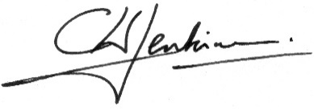

Craig Jenkinson, MA (Oxon), PGCE, MInstLM

The College
Abbey Gate College is the longest-running coeducational independent school in the Chester area, catering for circa 490 pupils aged 4-18 years. Set in the idyllic rural villages of Saighton and Aldford on the outskirts of Chester.

Our pupils are at the heart of everything we do. We believe education is about building self-esteem, a love of learning and igniting a desire in all our students, to ensure they fulfil their academic and personal potential. We strive to guarantee our children leave Abbey Gate College as confident, articulate, respectful and happy young high achievers.

From the youngest in Foundation to our Sixth Formers, we aim to develop skills for life; core values such as respect and compassion within the framework of an excellent education. Developing talents and skills in a wide range of areas are encouraged, success is celebrated and endeavour is recognised.

Abbey Gate College is committed to the safeguarding and promoting the welfare of children and expects all staff and volunteers to share this commitment.

Job Description and Person Specification – Head of Psychology
We are seeking an enthusiastic and committed (Part Time) Head of Psychology to join our College from 4th January 2022. The position is approx. 0.76 FTE (16 out of 21 lessons) over five days (Monday to Friday) to provide maternity cover. The successful candidate will lead Psychology at the College (one person department) and teach Sixth Form in the senior school.

Key responsibilities of the post-holder include:
- to provide inspirational teaching and leadership, and to foster a culture of excellence in staff and pupils alike;
- to take a lead in the future development of the Psychology Department and to show strategic vision, liaising with the Leadership Team as appropriate;
- to manage a departmental budget, to ensure effective economic expenditure and to lead and organise effective resourcing;
- to ensure the management and development of appropriate syllabuses, materials and schemes of work at A Level;
- to keep abreast of new trends and educational developments related to the subject;
- to ensure that the department is making effective and appropriate provision for SEND, Able and Talented and EAL learners;
- to ensure that the department is making effective and appropriate use of ICT;
- to enrich the curriculum offering by, for example, study visits, lectures and trips as appropriate;
- to promote the work of the department through displays of work within the department and in other appropriate venues throughout the College; whenever possible to enable pupils to participate in appropriate local and national competitions and events.
- to recruit Year 11 pupils to this subject offered at A Level at the Sixth Form Information Evening and taster days.
- To ensure that pupils are aware of the range of careers in Psychology and to assist in higher education applications.
- To maintain appropriate links with other departments;
- To ensure that the departmental area on the VLE is reviewed and updated on a regular basis.

Curriculum
Psychology is taught in the sixth form. The role is part time approx. 0.76FTE (16 out of 21 lessons) over five days (Monday to Friday).
A Level Psychology is taught to the AQA syllabus.

The successful candidate should be able to drive and maintain excellent results.

Key qualities and person specification:
The person appointed should have the following skills and qualities:-

- enthusiastic, caring, creative, and inspirational in their teaching
- strong academic profile, with subject-specialist expertise and ability to teach A Level
- committed to raising standards and monitoring pupil progress
- proven track record of excellence in support of examination success
- effective at adapting their teaching to suit the diverse needs of the pupils
- ability to inspire, as well as to support and encourage individuals
- excellent communication skills
- effective planning, time-management and organisational skills
- life-long learner, solution-orientated, and resourceful
- calm under pressure
- willingness to lead and manage extra-curricular sessions
- proficient with the use of ICT in the classroom (and remote teaching if required)
- confidence in using new technologies to share and promote good practice

Salary, Terms and Conditions
The salary for this position will depend upon the qualifications and relevant experience of the successful candidate.

Child Protection
Abbey Gate College regards as paramount the welfare and safety of children. Whilst criminal convictions are not necessarily a bar, this safety consideration will be key to all decisions regarding the employment of staff, approval of volunteers and standards of external contractors. An enhanced DBS check and barred check will be required for this role.

Equal Opportunities
We are committed to treating all employees with dignity and respect regardless of race, gender reassignment, pregnancy and maternity, age, sexual orientation, sex, religion or belief, marriage and civil partnership, disability. We therefore welcome applications from all segments of the community.

Process for Applications

Deadline: 1st October 2021
Interviews: TBC

Please apply by completing our Abbey Gate College application form along with a covering letter addressed to the Head, Mr Craig Jenkinson, explaining your interest and suitability for the role, and returning it to hr@abbeygatecollege.co.uk

The interview process will include; meetings with staff and school leadership, teaching an Art lesson, a tour of the College and, if applicable, an additional task. Specific details will be shared with shortlisted candidates in advance.

References for shortlisted candidates will be taken prior to interview; please inform your referees.

Please visit our website at www.abbeygatecollege.co.uk for more information about the College.

