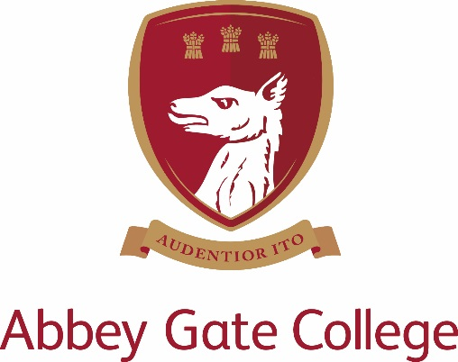

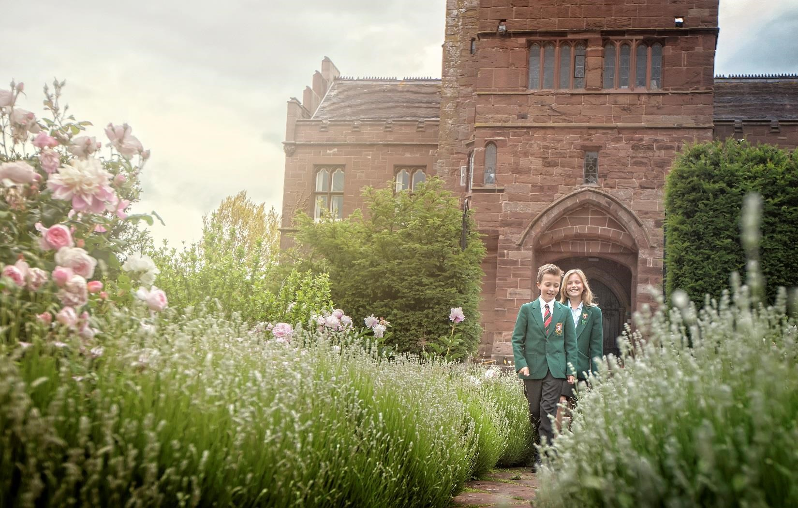

Receptionist/ Administrator (Term Time Only)

The College
Abbey Gate College is the longest-running coeducational independent school in the Chester area, catering for circa 485 pupils aged 4-18 years. Set in the idyllic rural villages of Saighton and Aldford on the outskirts of Chester.
Our pupils are at the heart of everything we do. We believe education is about building self-esteem, a love of learning and igniting a desire in all our students, to ensure they fulfil their academic and personal potential. We strive to guarantee our children leave Abbey Gate College as confident, articulate, respectful and happy young high achievers.
From the youngest in Foundation to our Sixth Formers, we aim to develop skills for life; core values such as respect and compassion within the framework of an excellent education. Developing talents and skills in a wide range of areas are encouraged, success is celebrated and endeavour is recognised.
Full Time (Term Time Only) - Receptionist/ Administrator
Our busy and vibrant Senior School requires a receptionist/administrator to provide a welcoming and informative environment for visitors and members of the school community. The role will assist with enquiries/queries from parents, pupils and visitors and will provide administrative assistance to the Leadership Team or Teaching staff/support staff when required.
The role will require;
- Answering the reception phone from external and internal callers
- Directing queries (via phone, email or face to face) to the correct staff member in a timely manner
- Being the point of contact at the reception desk to welcome visitors to the College and sign them in to the college and explain COVID19 procedures (including taking temperature of visitors and contractors).
- Reviewing incoming emails in the Admin email account and actioning them as required.
- Being a point of contact at the reception desk in regard to pupil and staff queries through the day.
- Directing pupils to First Aid or School Nurse if required.
- Overseeing the Infant and Junior school pupils (who have come up from the infant and junior school awaiting after school pick up) to ensure that they are picked up at the end of the day (and at the beginning of the day before school pick up by the transfer school bus if required).
- Action any required letters, emails or written communication/ paperwork as instructed by the Head, Leadership Team or staff member.
- Assist with any printing or photocopying if required.
- Any other duties as required.
This busy role requires a highly organised, customer service focused individual who is looking for a varied role in the nerve centre of the Senior School.
Skills and Experience
- An excellent standard of literacy and numeracy.
- Previous experience of working in a school or a busy reception area is preferred but not essential.
- Computer literate and proficient in all Microsoft packages (especially Word, Excel and Outlook, MS Teams) and ideally have used a school database system.
- Experience of operating a telephone system
- Excellent customer service skills and experience of working in a customer focused environment is essential.
- Excellent inter-personal skills
- General secretarial and administrative experience.
- Flexible approach
- Ability to manage workloads effectively and be highly organised.

Role
The role is term time only plus inset days. Holidays will be paid pro rata and are included in the salary.
Salary; £18000-£20000 FTE pro rata
Hours of work; 40 hours per week
8am to 5pm Monday to Friday (with one-hour unpaid lunchbreak).

Applications
Please complete the Abbey Gate College application form and return to Cherise Duffy, Human Resources and Compliance Manager at hr@abbeygatecollege.co.uk.

Closing Date: Monday 20th September 5pm.

