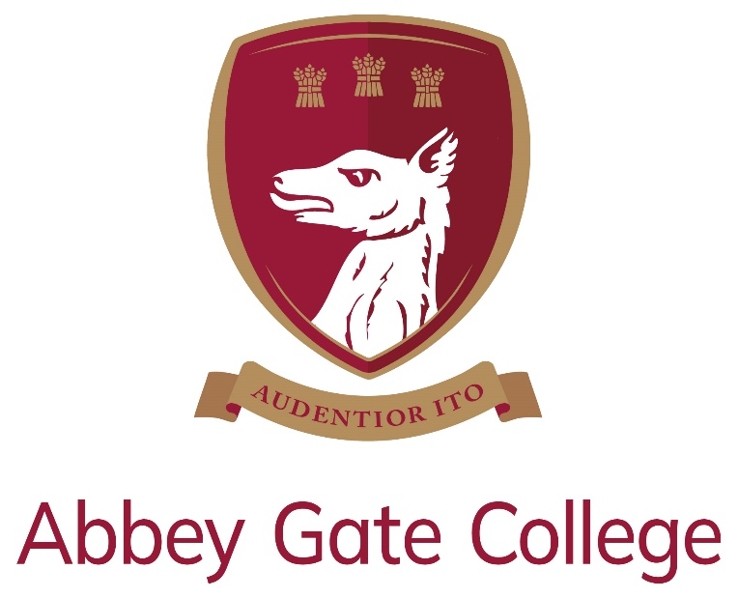

Job Description & Person Specification
Role | Cleaner
Contract | Permanent, part-time (term time plus 6 weeks)  30 hours per week (12.15pm until 6.15pm)
Start Date | Required to start as soon as possible
Salary | Hourly rate: £11.97  Based on 30 hours per week: £16,541

Introduction from the Head:
Our wonderful Senior School and Sixth Form are enviably located in the historic Saighton Grange buildings, with stunning views across beautiful countryside towards the Welsh mountains and the Cheshire sandstone ridge; and our dedicated Infant and Junior School is just down the road in the charming and picturesque village of Aldford.

Our College is a unique, inspiring, and memorable place to learn and grow, where our caring and committed teaching and support staff will do all that they can to help our pupils to be the best that they can be.

We are a safe and friendly school community, where we look out for each other and where we work with each child’s individual interests, passions, and strengths; while also encouraging them to try new things, take risks, and be creative.

Our Mission:
We are committed, within our safe and caring community, that each one of our pupils will become the best that they can be and have the self-belief to go forward into this changeable world with courage and with compassion.

Our Aims:
We pursue our whole College mission, guided by three defining and aspirational aims:

Thank you for taking the time find out more about us. If you feel that you could bring the right balance of care, commitment, expertise, and enthusiasm to this role, we would welcome your application.

Craig Jenkinson, MA (Oxon), PGCE, MInstLM, MCCT

The Post:
Abbey Gate College is looking to appoint a suitably experienced and skilled Cleaner to join our dedicated Estates Team. This post will be based at our Infant and Junior School in Aldford, but the successful candidate will be required to work at our Senior School in Saighton each afternoon, for approximately one to one-and-a-half hours, to assist our Senior School Cleaner following the lunch break. Both our Saighton and Alford sites are beautifully maintained and enjoyed by pupils, colleagues, and visitors alike.

Job Description:
Line managed by our Head Caretaker, the working pattern for this role is:

30 hours per week (12.15pm until 6.15pm)

We would welcome applications from interested parties wishing to work part time hours, as we are happy to consider a job share.

Our Cleaners are required to work during term time, plus an additional six weeks during school holiday periods, over a 12-month period.

Our Cleaners, along with the entire Estates Team, perform an essential role in ensuring that the College buildings are cleaned and maintained in optimum condition for use by our students and visitors.

Key Duties Include:
- Cleaning (vacuuming, mopping, buffing, wiping down, emptying bins, deep cleaning, etc.) in all areas of the buildings, including classrooms, communal areas, and toilets.
- Ensuring all areas are always cleaned to the highest standard.
- Notifying the Head Caretaker of any issues / damage requiring attention.
- Taking ownership of Health and Safety for yourself and others, observing and complying with site rules and regulations at all times.
- Checking stock levels of all consumables and replacing when appropriate.
- To work across both sites (Aldford and Saighton) to cover periods of absence of other Cleaners, and to assist our Senior School Cleaner for a short period each afternoon.
- Completing any other cleaning duties, as required.

Support for the College:
In addition to the day-to-day responsibilities of the role, you will also be expected to:
- Support the College’s commitment to safeguarding children and promoting their welfare in accordance with the College’s policies and procedures.
- Be aware of, and comply with, policies and procedures relating to health and safety, security, confidentiality, and data protection, reporting all concerns to the appropriate person.
- Contribute to the overall work and ethos of the Estates Team as required.
- To contribute to the overall vision, mission, and aims of Abbey Gate College.
- Participate in training, meetings, and performance development activities as required.
- Undertake any other duties as reasonably required.

Person Specification:
We are looking for people with a positive approach, a good knowledge of cleaning and high standards. We want the successful candidate to care about, and be proud of the wonderful, historic, educational facilities and operations of our College!

The successful candidate will possess the following:

Experience / Qualifications:
- Previous experience in a similar role would be an advantage, but is not essential, as training will be provided.
- A good working knowledge of Health and Safety is essential.
- An understanding of COSHH regulations is desirable.

Skills / Personal Qualities:
- Strong time management / organisational skills, with the ability to prioritise and meet deadlines whilst work under pressure.
- Attention to detail, accurate and methodical.
- Excellent communication and interpersonal skills.
- Ability to deal with sensitive information with the utmost discretion and to maintain confidentiality at all times.
- A team player, willing to support other members of the Estates Team, with the ability to work using their own initiative.
- Ability and willingness to adapt to and embrace change.
- Willingness to learn new skills and promote new initiatives.
- Willingness and adaptability in tackling the variety of tasks arising in a school environment.
- Willingness to be flexible regarding the variety of tasks arising within the College environment, and to be flexible regarding working hours, within reason, in response to the needs of the College.
- Willingness to attend evening meetings and events as required (not a frequent requirement).
- Commitment to CPD and training opportunities.
- Other requirements for the role are good communications skills and ability to work alongside other staff and contractors.

Salary:
The hourly rate for this position is £11.97 per hour.

The salary for 30 hours per week equates to: £16,541.

There may be the requirement to work additional hours to assist in the preparation of sites for important events, such as open days, at the College.

Workwear, equipment and personal protective equipment will be provided, and the post-holder is responsible for the maintenance and safety of these items.

The Cleaner will be driven between the Aldford and Saighton sites, each afternoon, by a member of the Estates Team, so this will not incur any expense on behalf of the successful candidate.

Safeguarding & Child Protection:
Abbey Gate College is committed, as a priority, to safeguarding and promoting the welfare of children, and expects all staff and volunteers to share this commitment.

Applicants will, therefore, be subject to stringent vetting and induction processes, including an enhanced DBS disclosure. References for shortlisted candidates will be requested prior to interview; please inform your referees.

Whilst criminal convictions are not necessarily a bar to appointment, this safety consideration will be central to all decisions regarding the employment of staff, approval of volunteers, and standards of external contractors.

Equality, Diversity & Inclusion:
We are committed to equality of opportunity for all staff and to treating all staff with dignity and respect. Therefore, applications from individuals are encouraged, regardless of age, disability, sex, gender reassignment, sexual orientation, pregnancy and maternity, race, religion or belief, and marriage and civil partnerships.

Process for Applications:

- Closing date for applications: Monday 15th April 2024 at midday.

In order to apply for our Cleaner vacancy, please complete our Abbey Gate College application form (available at https://www.abbeygatecollege.co.uk/about-us/vacancies/).

Please also include a covering letter, which should be addressed to our Head, Mr Craig Jenkinson, outlining your interest in, and suitability for, the role and the College.

Your completed application form and covering letter should be returned to Mrs Sue Moran, HR and Staff Wellbeing Manager, at: sue.moran@abbeygatecollege.co.uk by the above closing date.

Should you require any additional information or have any difficulties in completing / submitting your application, please also contact Sue Moran.

Please visit our website at www.abbeygatecollege.co.uk for more information about the College.

