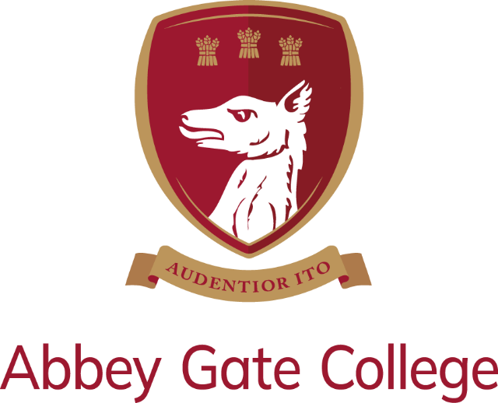

Job Description & Person Specification
Role | Teaching Assistant (including Breakfast Club supervision)
Contract | Permanent, term-time only, 12 hours 35 minutes per week
Start Date | September 2026
Salary | Based on 12 hours and 35 minutes per week, term-time only: £7,715 (based on the full-time, full-year salary of £30,489, which is Grade 4, Grade point 16 of the Abbey Gate College Support Staff Pay Scales).



Introduction from the Head of Abbey Gate College Infant and Junior School:

I would like to extend a very warm welcome to Abbey Gate College Infant and Junior School, which is situated in the beautiful, rural village of Aldford near Chester, just a short distance from our Senior School in Saighton Grange.

Set in extensive grounds, the school benefits from football pitches, a netball court, a wildlife garden and pond, a nature trail and an adventure playground. Our Junior pupils occupy the original village school, which has been sympathetically refurbished to provide a wonderful learning environment.

Hazeldine Lodge, opened in September 2018, is our purpose-built modern facility; home to our Reception and Infant pupils. Spacious classrooms, with patio doors leading out onto our outdoor learning areas and extensive grounds, ensure our youngest pupils have the best possible start to their education. All of our classrooms are welcoming and equipped with up-to-date technology, including Clever Touch Screens, to support learning.

Our Mission:
The development of the whole child is of great importance. All pupils at Abbey Gate College are regarded as individuals who are supported and encouraged, by our caring and committed teaching and support staff, to reach their full potential and be the best that they can be. In doing so, we aim to nurture and develop happy, confident, motivated and self-disciplined children who are considerate, tolerant and sensitive to the needs of others.

Our Aims:
We pursue our whole College mission, guided by three defining and aspirational aims:

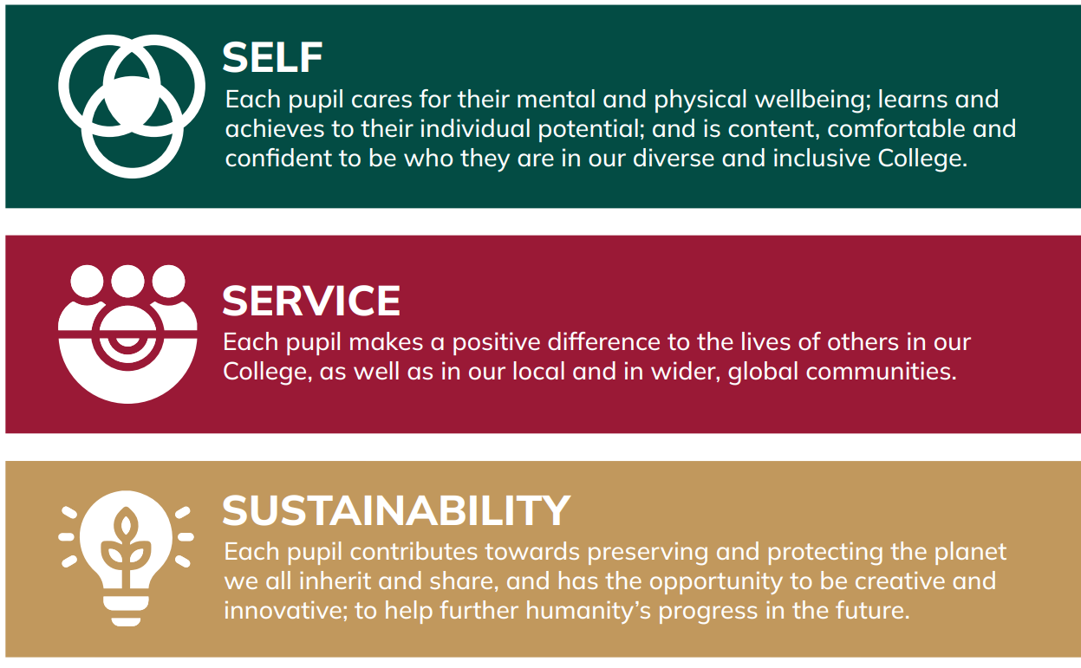

Thank you for taking the time to find out more about us. If you feel that you could bring the right balance of care, commitment, expertise and enthusiasm to this role, we would welcome your application.

Corinna Travis, Head of Infant and Junior School
The Post:
The College is seeking to appoint suitably qualified, part-time Teaching Assistant, working 12 hours and 35 minutes per hours per week, term-time only.

The ideal working pattern would be as follows:

Mondays and Thursdays
Breakfast Club – 7.45am – 8.30am
Teaching Assistant - 8.30am – 12.30pm

Tuesdays
Breakfast Club – 7.45am – 8.30am
Teaching Assistant - 8.30am – 10.50am

The Teaching Assistant aspect of the role will have a particular emphasis on supporting pupils with literacy and numeracy in the classroom. Therefore, candidates should be suitably qualified, experienced and enthusiastic, in order to effectively support pupils within the classroom.

The Breakfast Club supervision role involves supervising pupils before lessons start, organising games and activities, serving breakfast (toast, drinks, etc.), and ensuring pupils have a positive and calm start to their day.

The Infant and Junior School consists of seven classes from Foundation to J6. Small class sizes and specialist teachers ensure we offer our children a broad and balanced curriculum, which aims to develop the full potential of each and every pupil.

Spiritual, moral, social, and physical development form an important part of the curriculum and help to prepare pupils for the challenges and experiences of later life.

Key Qualities and Person Specification:
- Teaching Assistant qualification.
- Experience of supporting primary school aged pupils within the classroom.
- Relevant training and experience of working with pupils from 4 to 11 years old.
- Be prepared to complete online basic food hygiene training.
- Be a creative, hardworking, lateral thinker.
- Be proficient and confident with the use of ICT in the classroom.
- Have excellent personal organisational skills.
- Be able to demonstrate effective interpersonal / communication skills.
- Be adaptable, with a good sense of humour and able to take the initiative.
- Have the ability to enable and promote independent learning.
- Be a very good team worker, with the capacity to build relationships at all levels across the school.

Outline of Role and Key Responsibilities:
The successful candidate will:

- Help and contribute to creating and managing a caring, supportive, purposeful and stimulating environment, which is conducive to pupils’ learning.
- Identify clear teaching objectives and learning outcomes, with appropriate challenge and high expectations, as agreed with class teacher.
- Help to enable pupils to develop and maintain positive attitudes towards learning.
- Help to prepare resources, as directed by the class teacher.
- Be part of a whole school team, actively involved in the preparation and development of teaching materials and resources, as appropriate.
- Attend and participate in staff meetings, briefings, planning meetings and Staff CPD days, as appropriate.
- Ensure that school policies are reflected in daily practice.
- Help with outings and sporting events, if relevant
- Comply with school policies and procedures and ensure they are reflected in daily practice.

Terms & Conditions:

Remuneration
Based on 12 hours and 35 minutes per week, term-time only: £7,715 (based on the full-time, full-year salary of £30,489, which is Grade 4, Grade point 16 of the Abbey Gate College Support Staff Pay Scales).

Employee Benefits
- Beautiful buildings and stunning grounds in a rural setting, just outside of Chester
- Friendly and supportive colleagues with a strong community feel
- Small class sizes
- Respectful, and friendly pupils
- Complementary lunch for all colleagues
- A Defined Contribution Pension Scheme, with Royal London, with an 7% employer’s contribution and a minimum employee’s contribution of 3% (AVCs optional)
- A Death in Service benefit of 3 x annual salary
- Discounted school fees
- Access to our extensive Employee Assistance Programme, including counselling provision
- Trade Union Recognition

Applicants are recommended to read the College’s most recent ISI inspection report, from November 2025, which describes further the unique ethos of our school (available at: https://www.abbeygatecollege.co.uk/about-us/inspection-reports/).

Safeguarding & Child Protection:
Abbey Gate College is committed, as a priority, to safeguarding and promoting the welfare of children, and expects all staff and volunteers to share this commitment.

Applicants will, therefore, be subject to stringent vetting and induction processes, including an online search and an enhanced DBS disclosure.

Shortlisted candidates will be asked to complete a criminal records self-declaration form prior to interview. References for shortlisted candidates will be requested prior to interview; please inform your referees.

Whilst criminal convictions are not necessarily a bar to appointment, this safety consideration will be central to all decisions regarding the employment of staff, approval of volunteers, and standards of external contractors.

Equality, Diversity & Inclusion:
We are committed to equality of opportunity for all staff and to treating all staff with dignity and respect. Therefore, applications from individuals are encouraged, regardless of age, disability, sex, gender reassignment, sexual orientation, pregnancy and maternity, race, religion or belief, and marriage and civil partnerships.

Process for Applications:
The closing date for applications is Tuesday 4th August 2026 at midday.

In order to apply for our Teaching Assistant vacancy, please complete our Abbey Gate College application form (available at https://www.abbeygatecollege.co.uk/about-us/vacancies/).

Please also include a covering letter, which should be addressed to the Head of the Infant and Junior School, Mrs Corinna Travis, outlining your interest in, and suitability for, the role and the College.

Your completed application form and covering letter should be returned to Mrs Sue Moran, HR and Staff Wellbeing Manager, at: sue.moran@abbeygatecollege.co.uk by the above closing date.

Should you require any additional information or assistance regarding your application, please also contact Sue Moran.

Please visit our website at www.abbeygatecollege.co.uk for more information about the College.

