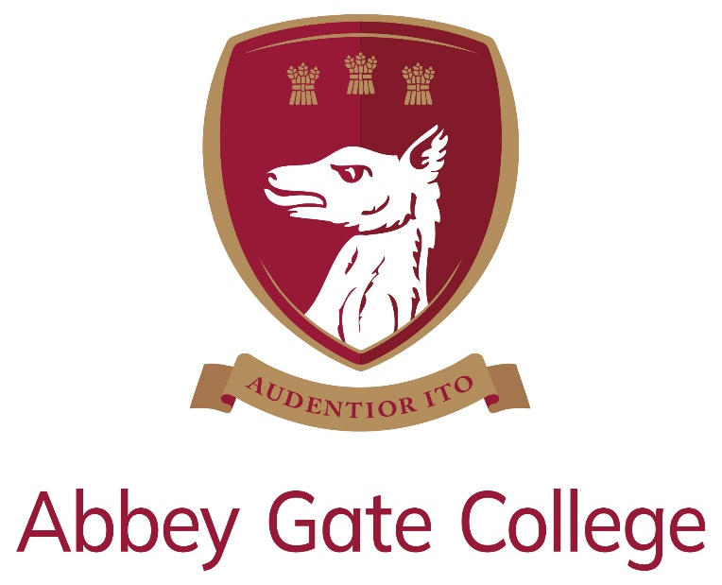

Job Description & Person Specification
Role | Weekend Caretaker
Contract | Permanent, part time – 16 hours / 2 days per week on a full year basis
Start Date | Required to start as soon as possible
Salary | £11.826 based on 16 hours per week, on a full year basis, i.e. during term time and school holidays (based on the full-time, full-year salary of £27,717, which is Grade 3, Grade point 11 of the Abbey Gate College Support Staff Pay Scales).

Introduction from the Head:

Our wonderful Senior School and Sixth Form are enviably located in the historic Saighton Grange buildings, with stunning views across beautiful countryside towards the Welsh mountains and the Cheshire sandstone ridge; and our dedicated Infant and Junior School is just down the road in the charming and picturesque village of Aldford.

Our College is a unique, inspiring, and memorable place to learn and grow, where our caring and committed teaching and support staff will do all that they can to help our pupils to be the best that they can be.

We are a safe and friendly school community, where we look out for each other and where we work with each child’s individual interests, passions, and strengths; while also encouraging them to try new things, take risks, and be creative.
Our Mission:
We are committed, within our safe and caring community, that each one of our pupils will become the best that they can be and have the self-belief to go forward into this changeable world with courage and with compassion.

Our Aims:
We pursue our whole College mission, guided by three defining and aspirational aims:

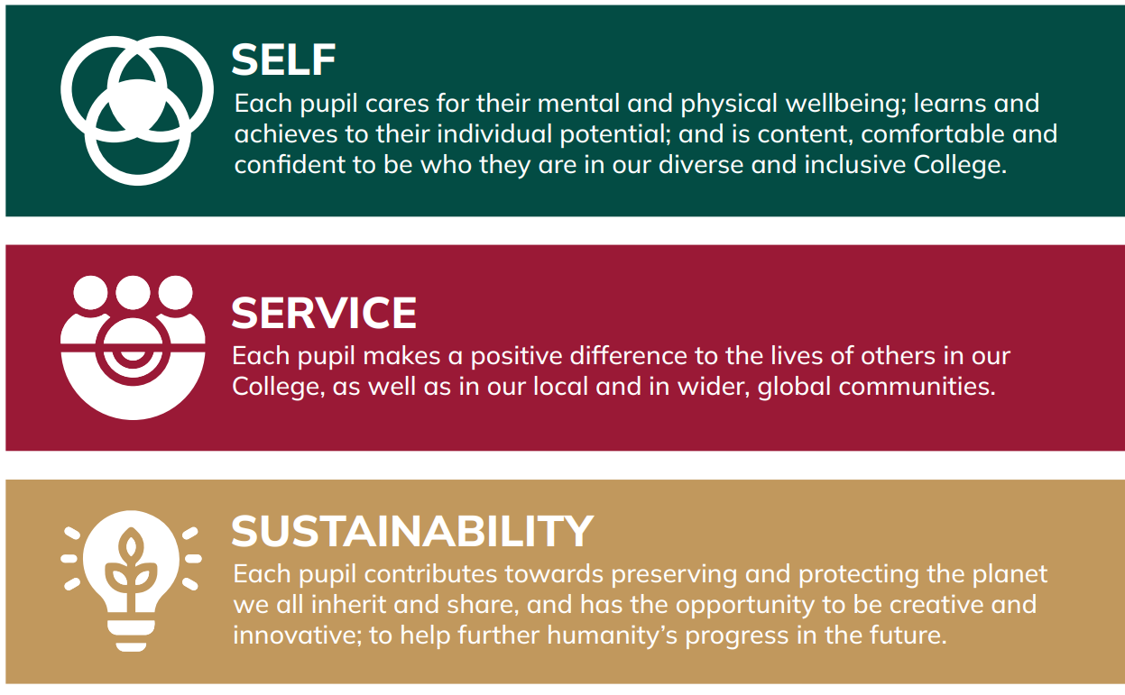

Thank you for taking the time find out more about us. If you feel that you could bring the right balance of care, commitment, expertise, and enthusiasm to this role, we would welcome your application.



Craig Jenkinson, MA (Oxon), PGCE, MInstLM, MCCT

The Post:
Abbey Gate College is looking to appoint a suitably experienced and skilled person to join our dedicated Estates Team.

This role involves working on a Saturday and Sunday, assisting external hires using the College’s sports and performing arts facilities, as well as carrying out general caretaking responsibilities, as needed.

The aim is to ensure that any hirer's overall experience of facility use is positive, such that we may retain their custom and they may recommend us further.

A caring, warm and professional manner is required at all times. Therefore, excellent customer service skills are essential.

Line managed by our Head Caretaker, the role will involve working closely with the Estates Manager and other members of the Estates Team.

Key Duties:
- Opening / locking up all buildings, ensuring site is completely secured, and all alarms are correctly set before the site is vacated.
- Meeting and greeting site hirers and their visitors, supporting throughout to ensure that any hirer's overall experience of facility use is positive, such that we may retain their custom and they may recommend us further.
- Ensuring on site hirers and their visitors comply with all College guidelines and Hire Agreement rules across the whole of the site.
- Janitorial duties.
- Ensuring that the site is always kept clean and tidy, including litter collection, emptying bins, removing all waste etc. ensuring all areas are ready for College activities after hirers have used the site.
- Cleaning tasks, as required including mopping, cleaning surfaces, vacuuming, cleaning / checking of minibuses, etc.
- Moving and setting out of staging, chairs and tables for all College events, as and when required, using correct manual handling techniques.
- Carrying out maintenance and equipment checks ensuring any issues are reported correctly, and accurate records are maintained.
- Ensuring that the College complies with all current legislation in relation to Health & Safety and maintaining appropriate records and checks.
- Any other duties as required.

Support for the College:
In addition to the day-to-day responsibilities of the role, you will also be expected:
- To support the College’s commitment to safeguarding children and promoting their welfare at a level appropriate to this role.
- To be aware of, and comply with, policies and procedures relating to health and safety, security, confidentiality, and data protection, reporting all concerns to the appropriate person.
- To be involved in wider College financial developments and initiatives.
- To support the College in its aims and objectives.
- To contribute to and promote the overall ethos / work / aims of Abbey Gate College.
- To comply with the College’s Staff Code of Conduct and exercise mutual respect of pupils and staff.
- To participate in training, meetings, and performance development activities, as required, and attend College CPD days.
- To undertake such duties as may, from time to time, reasonably requested within the level of the post.

Person Specification:
We are looking for somebody with a positive, proactive approach, who will work effectively as part of our Estates Team. We want the successful candidate to care about, and be proud of the wonderful, historic, educational facilities and operations of our College!

The successful candidate will possess the following:

Experience / Qualifications:
- Previous experience in a similar role (caretaking / facilities role / cleaning) would be an advantage.
- A good working knowledge of Health and Safety is essential.
- A basic Health and Safety / First Aid qualification is desirable.
- An understanding of COSHH regulations is desirable.

Skills / Personal Qualities:
- Excellent inter-personal, communication and organisational skills.
- Punctuality and reliability are essential.
- Ability to plan work under own initiative
- Ability to deal with sensitive information with the utmost discretion and to maintain confidentiality at all times.
- Willingness and adaptability in tackling the variety of tasks arising in a school environment.
- Willingness to be flexible regarding the variety of tasks arising within the College environment, and to be flexible regarding working hours, within reason, in response to the needs of the College.
- Commitment to CPD and training opportunities.

Safeguarding & Child Protection:
Abbey Gate College is committed, as a priority, to safeguarding and promoting the welfare of children, and expects all staff and volunteers to share this commitment.

Applicants will, therefore, be subject to stringent vetting and induction processes, including an enhanced DBS disclosure. References for shortlisted candidates will be requested prior to interview; please inform your referees.

Whilst criminal convictions are not necessarily a bar to appointment, this safety consideration will be central to all decisions regarding the employment of staff, approval of volunteers, and standards of external contractors.

Shortlisted candidates will be asked to complete a criminal records self-declaration form prior to interview.

A social media search will be completed for all shortlisted candidates.

Equality, Diversity & Inclusion:
We are committed to equality of opportunity for all staff and to treating all staff with dignity and respect. Therefore, applications from individuals are encouraged, regardless of age, disability, sex, gender reassignment, sexual orientation, pregnancy and maternity, race, religion or belief, and marriage and civil partnerships.

Terms & Conditions:

Remuneration
£11.826 based on 16 hours per week, on a full year basis, i.e. during term time and school holidays (based on the full-time, full-year salary of £27,717, which is Grade 3, Grade point 11 of the Abbey Gate College Support Staff Pay Scales).

The working pattern for this role is as follows:

Saturday – 08.30 – 18.30 (inclusive of a one-hour unpaid lunchbreak).

Sunday – 09.00 – 16.30 (inclusive of a 30-minute unpaid lunch break).

On occasion, there may be a requirement to work additional hours (usually for one-off events) for which notice would be provided, and a timesheet will be submitted for payment for any additional hours worked.

The ability to be flexible with hours / days worked would be advantageous. Should you have any questions regarding the working hours or pattern for this role, please contact our HR & Staff Wellbeing Manager, Mrs Sue Moran, at: sue.moran@abbeygatecollege.co.uk
Hours of work may vary during school holidays, and this will be confirmed, with notice, by the Estates Manager, to ensure that maintenance, project work and cleaning is completed across both sites as required.

This post will be based at our Senior School in Saighton, but there may be the occasional need for support at our Infant and Junior School in Aldford. Both our Saighton and Aldford sites are beautifully maintained and enjoyed by pupils, colleagues and visitors alike.

Employee Benefits
- Beautiful buildings and stunning grounds in a rural setting, just outside of Chester
- Friendly and supportive colleagues with a strong community feel
- Small class sizes
- Respectful, and friendly pupils
- A Defined Contribution Pension Scheme, with Royal London, with an 7% employer’s contribution and a minimum employee’s contribution of 3% (AVCs optional)
- A Death in Service benefit of 3 x annual salary
- Discounted school fees
- Access to our extensive Employee Assistance Programme, including counselling provision
- Trade Union Recognition

Applicants are recommended to read the College’s most recent ISI inspection report, from November 2025, which describes further the unique ethos of our school (available at: https://www.abbeygatecollege.co.uk/about-us/inspection-reports/).

Process for Applications:

- Closing date for applications: Tuesday 4th August 2026 at midday

In order to apply for this vacancy, please complete our Abbey Gate College application form (available at: https://www.abbeygatecollege.co.uk/about-us/vacancies/).

Please also include a covering letter, which should be addressed to our Head, Mr Craig Jenkinson, outlining your interest in, and suitability for, the role and the College.

Your completed application form and covering letter should be returned to Mrs Sue Moran, HR and Staff Wellbeing Manager, at: sue.moran@abbeygatecollege.co.uk by the above closing date.

Should you require any additional information or assistance regarding your application, please also contact Sue Moran. Please visit our website at www.abbeygatecollege.co.uk for more information about the College.

